# CS 340 README Template

## About the Project/Project Title

This project is an application that will allow access to a file by the user. This access is from a local Mongo database. The users can be the administrator or the aacuser, each one with different authentication. Throughout this module we create a CRUD, meaning we can create, read, update, and delete documents from the database. We also created an interactive dashboard with a Python Module that use the dataset provided. In this dashboard we added geolocation and a chart for the database.

## Motivation

The project exists to learn how to develop a CRUD module for our first project in the class. The project is intended to teach how to develop a database using MongoDB and how to implement the CRUD functions. Within the project we imported a database, created users for the database and learn how to work with the database.

We also learn how to create a Python Module that produce a dashboard by importing Dash function. Dash is the frontend of the project. We created a data table with the data from the database that is interactive allowing us to sort and choose from the dataset to display in a chart and the geolocation map.

## Getting Started

1. First, we must have all the necessary components to work with the database, in this case MongoDB, Python, PyMongo and we are using Jupiter Notebook.
2. We need to import the database and Initiate the Mongo server.
3. Start the server with authorization for the user after creating the user.
4. Import the database we are going to use and modify.
5. Go to python and create the module for the CRUD function and test it with Jupiter Notebook.

(Make sure PyMongo driver is installed, that you have Python 3)

1. Create the dashboard by importing Dash into our Python Module. Dash helps creating interactive dashboard. (frontend)
2. Create A dashboard that is interactive with a geolocation map and a chart.

## Installation

We are using a Linux Shell to use MongoDB, we used Python to create a Python Module and Jupiter to create and run the test scrip for our Python driver. The driver is called PyMongo and is used to glue Python with MongoDB. After that we created a dashboard using Dash functions. The dashboard is interactive and let you sort and choose from the database to check the location of the animals in the datasets.

Links:

<https://www.mongodb.com/>

<https://www.python.org>

<https://jupyter.org>

<https://dash.plotly.com/introduction>

## Usage

Dashboard layout and data table creation.

Here is the dashboard callback

## 

Callback for the char and the Geolocation Map

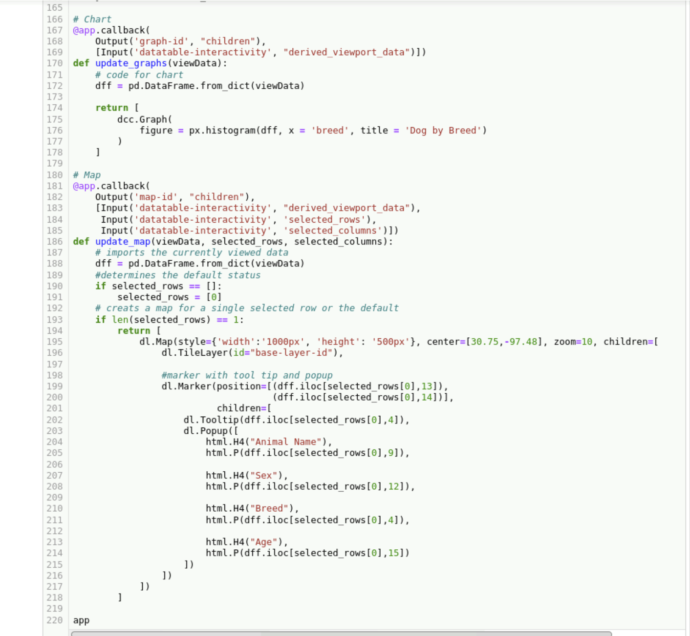

The result of the work Done is a Data Table with the data set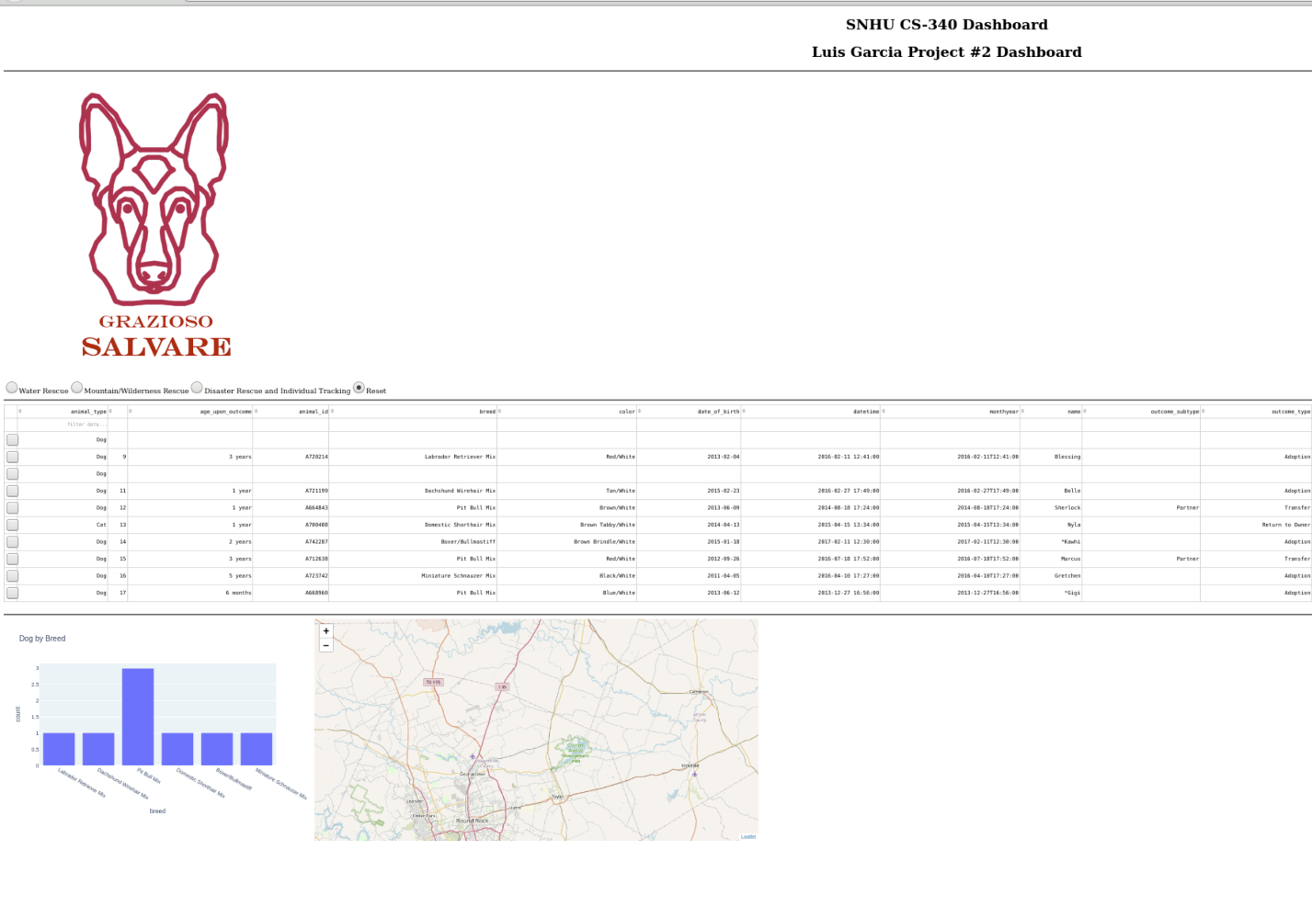

(Is interactive, so if we choose from the list, we can sort the dataset).

MongoDB is use as the database for our project. Using the user created in the mongo shell we can access the datasets and use them in our data table. We access the dataset by creating a Python Module that works as the glue between the database created in MongoDB. This Python file have the CRUD functions. The Python Module that we created in Jupyter is used to create the frontend of the project. This front end is the data table created with Dash to provide not only the data table, but the interactive chart and the geolocation map. The result is an interactive data table that works with the chart and the map.

## Contact

Your name: Luis Garcia, Luis.garcia6@snhu.edu